

**Year 7 Earth and Space Sciences 2022**

***Mid-Term Test***

**Section 1: Multiple Choice Answers 1 mark each**

*Read all answers and choose the* ***BEST*** *one.*

1. Earth’s axis is tilted at an angle of 23.5°. Imagine it didn’t tilt. Which of the following statements would then be true?
2. Earth would have the same seasons as it does now.
3. Earth’s seasons would be longer than they are now.
4. Earth would not have any seasons at all.
5. The length of the day would change.
6. Which of the following has a gravitational field around it?
7. Sun
8. the Earth
9. the person sitting next to you
10. Everything with mass has a gravitational field.
11. The main influence on the Earth’s tides is the gravitational force of the:
12. Moon
13. Sun
14. Earth
15. Oceans
16. As you move away from Earth, its gravitational field:
17. gets stronger
18. weakens
19. always stays the same
20. is zero
21. In the Noongar Calendar, it is now Djerin, where nights become cooler and families would move inland along the Swan River. How many seasons are found in the Noongar Calendar?
22. 3
23. 4
24. 6
25. 12

**Use the following diagram to answer questions 6 to 9.**

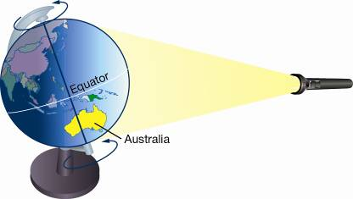*The diagram below shows a model that was constructed to demonstrate the effect of the Earth’s tilted axis. A torch is used to represent the Sun.*

1. In this position, Australia is experiencing:
2. night
3. day
4. winter
5. There is not enough information to decide
6. In the model above, what time of day is it in Perth, Western Australia?
7. midday
8. after sunset
9. midnight
10. early morning
11. In the model above, what season is it in Australia when it is in this position?
12. autumn
13. summer
14. winter
15. It is not possible to determine the season from this model.
16. A complete cycle of phases of the Moon occurs once in
17. 27.3 days
18. 28.0 days
19. 29.5 days
20. 31.0 days

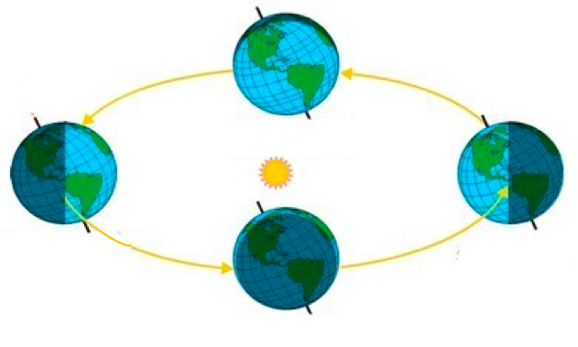***For questions 10 to 13*** *use the diagram below which shows the Earth in 4 positions while revolving around the sun:*

**4**

**3**

**1**

**2**

1. Which of the following will the Southern Hemisphere experience when at position 1?
2. Autumn Equinox.
3. Summer Solstice.
4. Winter Solstice.
5. Spring Equinox.
6. Which of the following will the Southern Hemisphere experience when at position 2?
7. Autumn Equinox.
8. Summer Solstice.
9. Winter Solstice.
10. Spring Equinox.
11. Which of the following will the Southern Hemisphere experience when at position 3?
12. Autumn Equinox.
13. Summer Solstice.
14. Winter Solstice.
15. Spring Equinox.
16. At which position will the hours in the day equal the hours at night time for the Southern Hemisphere?
17. 4
18. 3
19. 2
20. Both A and C
21. 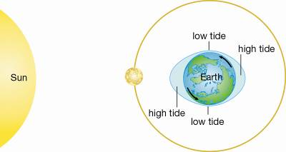The type of tide shown in the diagram below is:
22. low tide.
23. spring tide.
24. neap tide.
25. leap tide.
26. The phase of the moon in the above Question 14 picture is:
27. new moon.
28. first quarter.
29. full moon.
30. last quarter.
31. The type of tide shown in the diagram below is:

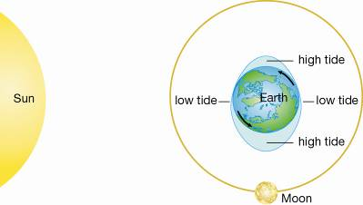

1. low tide.
2. spring tide.
3. neap tide.
4. leap tide.
5. Which is true during the spring tide:
6. The moon and sun’s gravitation pull combines, and low tides are not as low and high tides not as high.
7. The moon and sun’s gravitation pull cancel each other, and low tides are not as low and high tides not as high.
8. The moon and sun’s gravitation pull combines, and low tides are very low and high tides very high.
9. The moon and sun’s gravitation pull cancel each other, and low tides are very low and high tides very high.
10. Which is true during the neap tide:
11. The moon and sun’s gravitation pull combines, and low tides are not as low and high tides not as high.
12. The moon and sun’s gravitation pull cancel each other, and low tides are not as low and high tides not as high.
13. The moon and sun’s gravitation pull combines, and low tides are very low and high tides very high.
14. The moon and sun’s gravitation pull cancel each other, and low tides are very low and high tides very high.
15. When viewed from the Earth, the Moon appears to rise in the east and set in the west daily.  
     This is because:
16. the Moon revolves around the Earth
17. the Earth rotates on its axis
18. the Earth revolves around the Sun
19. the Moon rotates on its axis
20. If the Moon is in the last quarter phase on the 7th of November, on what day (approximately)  
     will the Moon be full?
21. November 14th
22. November 21st
23. November 28th
24. December 7th

1. As seen from the Earth, the Moon seems to change shape during the month because of:
2. the turning of the Earth on its own axis
3. the shadow of the Earth falling on the Moon
4. the changing positions of the Earth, Sun and Moon
5. the turning of the Moon on its own axis
6. If we see the first quarter Moon tonight, which phase of the Moon will people on the other  
    side of the Earth see when night arrives for them?
7. a crescent Moon
8. a first quarter Moon
9. a gibbous Moon
10. a last quarter Moon
11. Earth rotates from:
12. North to South
13. East to West
14. West to East
15. South to North
16. The same side of the Moon always faces Earth because the Moon's period of revolution
17. is longer than the Moon's period of rotation
18. equals the Moon's period of rotation
19. is longer than Earth's period of rotation
20. equals Earth's period of rotation
21. Which of these is a TRUE statement?
22. The moon makes its own light.
23. The moon gets bigger and smaller.
24. The moon reflects light from the sun.
25. The moon is made of cheese.
26. The ocean water near the equator absorbs more heat throughout the year than water near  
     the poles. This is best explained by which of the following:
    1. the equator is closer to the sun
    2. the equator has higher sea levels
    3. the equator receives more direct sunlight
    4. the equator rotates more quickly on the earth's axis
27. What is the term used to describe the moon as it changes from a new moon to a full moon?
28. waxing
29. waning
30. spring
31. neap
32. What is the maximum percentage of the Moon’s surface that may be seen from Earth?
33. 10%
34. 100%
35. 25%
36. 50%

**- End of Multiple-Choice Section -**

|  |  |
| --- | --- |
| Mount Lawley Senior High School - Wikipedia | **Mount Lawley Senior High School** |
| **Year 7 2022 – Earth and Space Science – Mid-Unit Test**  **Earth in Space** |
| Name: ___________________________________________________________  Class: _____________________________ Date:_____________________ |

***Section A: Multiple Choice – Please SHADE the best suited answer* 28 marks**

1. A B C D
2. A B C D
3. A B C D
4. A B C D
5. A B C D
6. A B C D
7. A B C D
8. A B C D
9. A B C D
10. A B C D
11. A B C D
12. A B C D
13. A B C D
14. A B C D
15. A B C D
16. A B C D
17. A B C D
18. A B C D
19. A B C D
20. A B C D
21. A B C D
22. A B C D
23. A B C D
24. A B C D
25. A B C D
26. A B C D
27. A B C D
28. A B C D

**Multiple Choice: ________ /28**

**Short Answer: ________ / 22**

**TOTAL: / 50**

**Section 2: Short Answer Total 22 marks**

1. **State** how long Earth takes to: (2 marks)

**1 year/ 365.25 days**

**24 hours/1 day**

a) rotate once on its own axis: _____________ b) travel once around the Sun: ____________

2. a) **Define** the term *Rotation (do not use the word ‘rotate’ in your answer* (1 mark)

When an object **spins/turns around** ( ½ mark) it’s **axis** ( ½ mark)

______________________________________________________________________________

b) **Define** the term *Revolution* *(do not use the word ‘revolve’ in your answer)*  (1 mark)

When an object **orbits** (1 mark) another object.( ½ mark if did not use ‘orbit’ eg, circles around)

______________________________________________________________________________

c) **State two examples** of space objects/bodies that orbit a different space object/ body (state both objects).eg ‘The Earth orbits the Sun’ – *do not use this for your answer* (2 marks)

½ mark for the object, ½ mark for the object it revolves around.

Moon orbit sun = ½

1. a)____________________________________________________________________________b) ___________________________________________________________________________
2. 3. **Describe** the Earth’s position when we experience: (2 marks)

Earth is **facing towards** the sun

Day time: ______________________________________________________________________

Earth is **facing away** from the sun

**Not** about tilt or hemispheres!

Night time: _____________________________________________________________________

**4. Name** the Phases of the moon *(As seen from Australia)*: (4 marks)

½ marks if waxing and waning are swapped ONLY IF the crescent/gibbous parts are correct

Double up’s receive no marks.

Full Moon 1st Quarter Waxing Gibbous Waxing Crescent

New Moon 3rd/Last Quarter Waning Crescent Waning Gibbous

5. If the last high tide was at 1.00pm, approximately what time will the next: (2 marks)

1.00 am (1.25am is more accurate)

a) high tide be? ___________

7.00 pm (7.12pm is more accurate)

b) low tide be? ___________

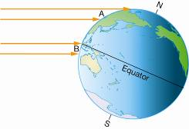

**Sunlight**

**Diagram for Question 6**

6. **State** the season in each hemisphere shown in the diagram above: (2 marks)

**Winter**

**Summer**

Northern: ________________ Southern: ________________

7. If the Earth’s tilt changed to 35o **predict how and explain why** the seasons would be different in each hemisphere as shown in the diagram below. (4 marks)

**Sunlight**

**Diagram for Questions 7**

________________________________________________________________________________________________________________________________________________________________________________________________________________________________________________________________________________________________________________________

Northern hemisphere **gets less direct sunlight (1/2)– winter colder (1/2) days shorter (1/2)**

**continuous nights closer to North pole(1/2)**

Southern hemisphere **gets more direct sunlight (1/2) – summer hotter (1/2) days longer (1/2)**

**Continuous days closer to South Pole (1/2)**

______________________________________________________________________________

____________________________________________________________________________________________________________________________________________________________ ______________________________________________________________________________

**8. Identify** the phase of the moon in each of the pictures below: (2 marks)

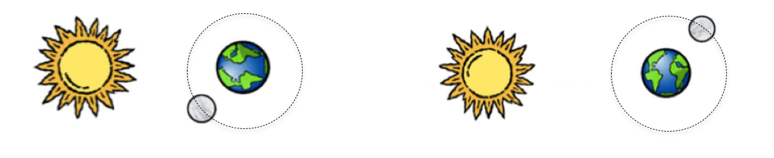

½ marks if waxing and waning are swapped ONLY IF the crescent/gibbous parts are correct

Waning Gibbous

Waxing Crescent

a) _______________________________ b) ______________________________

***- End of Test –***